Selecting the S3 bucket you want to delete

* Choose the bucket

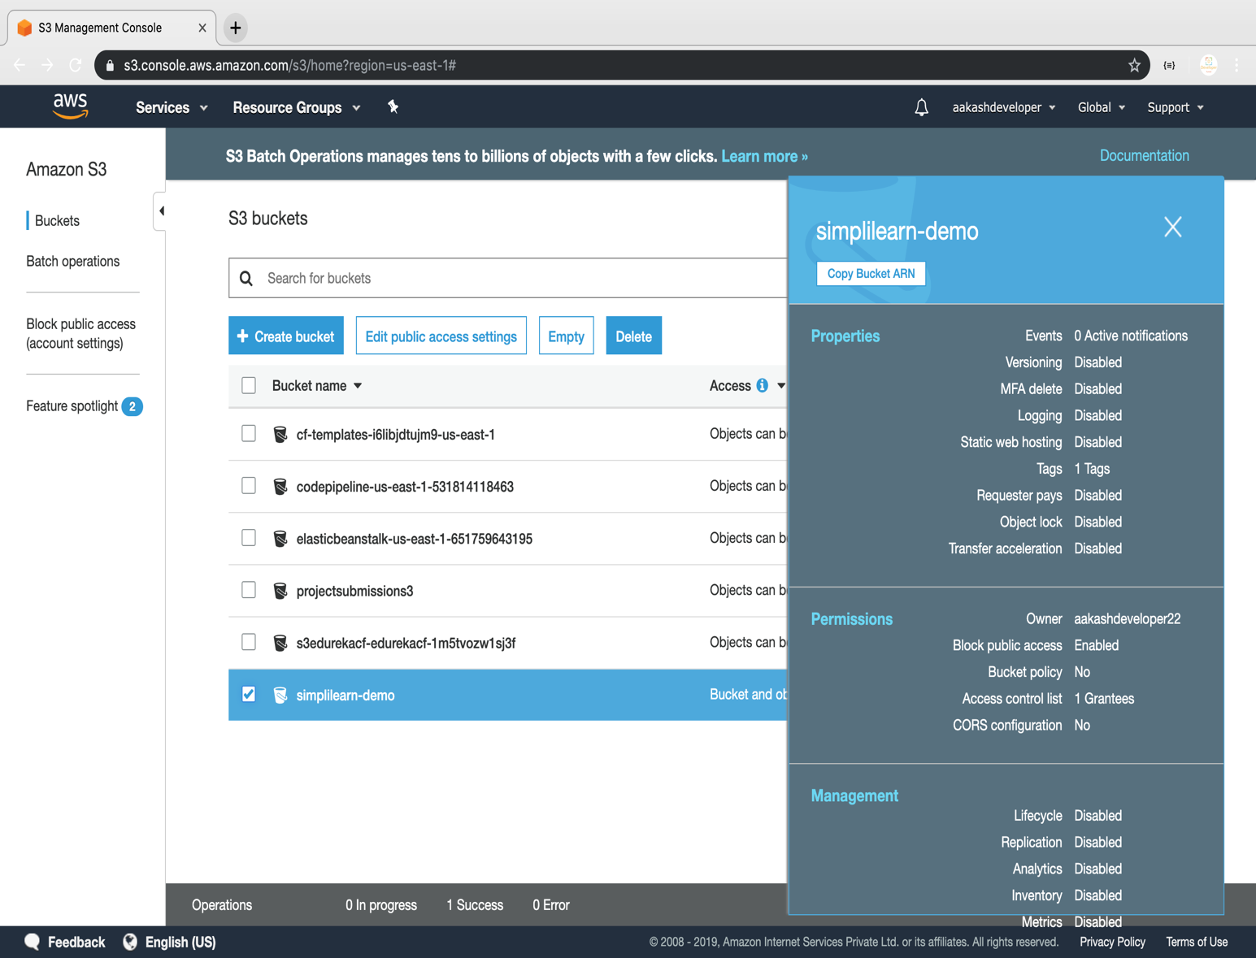

Deleting the bucket

